**Section A : Listening (25 marks)**

**(A) Listen to the text and read the questions. Circle the correct answer. (12 marks)**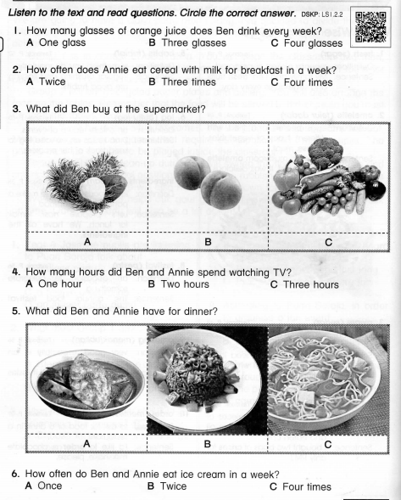

**(B) Listen and tick to the correct answer. (4 marks)**

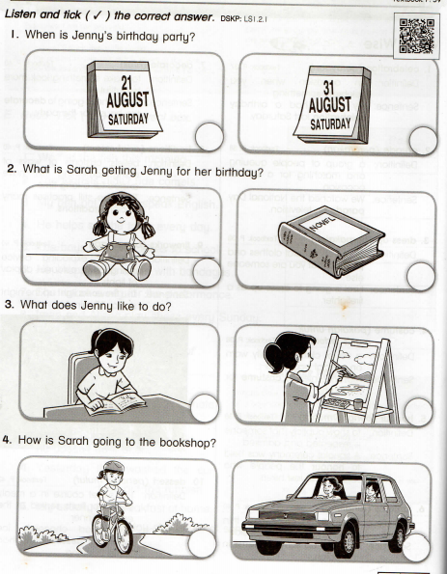

**(C) Listen to the dialogue. Write ‘True’ or ‘False’ for each statement.**

**(4 marks)**

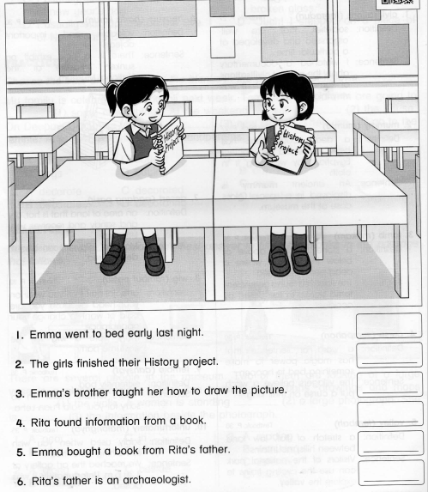

**(D) Listen and circle a or b. (5 marks)**

1. **When is Alice’s birthday?**
2. **5 February b. 6 February**
3. **Is Alice going to have a costume party?**
4. **Yes, she is. b. No, she isn’t.**
5. **Is Tom going to make sandwiches for Alice’s party?**
6. **Yes, he is. b. No, he isn’t.**
7. **Is Alice going to buy a birthday cake?**
8. **Yes, she is. b. No, she isn’t.**
9. **When is Alice’s birthday party?**
10. **Saturday b. Friday**

**Section B : Reading (25 marks)**

**(A) Choose the best answer for each sentence. (14 marks)**

**1. She likes rambutan __________ not guava.**

**a. and b. but**

**2. Jeevan _________ his classmates are at the museum.**

**a. and b. but**

**3. Amin speaks English, ________ he doesn’t do it often.**

**a. and b. but**

**4. Yesterday they washed the car ________ took out the rubbish.**

**a. and b. but**

**5. Deen ________________ the fire works.**

**a. is going to watch b. are going to watch**

**6. She _____________ her bicycle tomorrow.**

**a. is going to ride b. are going to ride**

**7. We __________ a new computer game.**

**a. is going to play b. are going to play**

**8. My parents _____________ in the park with me.**

**a. is going to jog b. are going to jog**

**9. There is ________ watermelon juice in the jug.**

**a. some b. any**

**10. Is there _______ pizza on the plate?**

**a. some b. any**

**11. There aren’t _______ apples. Let’s buy _______ apples.**

**a. any, some b. some, any**

**12. There are _______ burgers but there isn’t _______ ketchup in the bottle.**

**a. any, some b. some, any**

**(B) Read the text.** 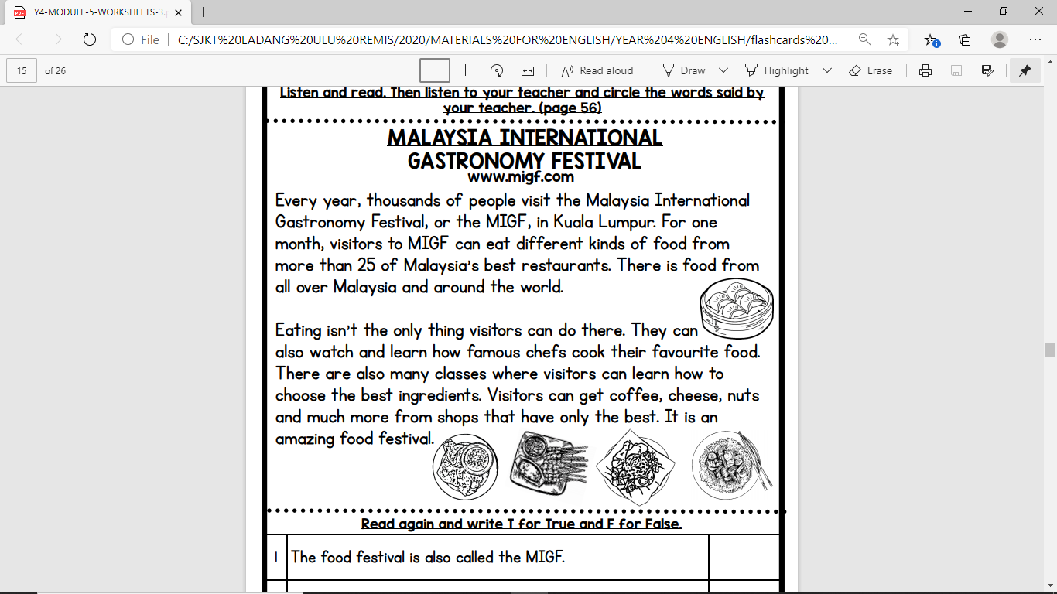

**Read the text again and write T for True statements and F for false statements. (6 marks)** 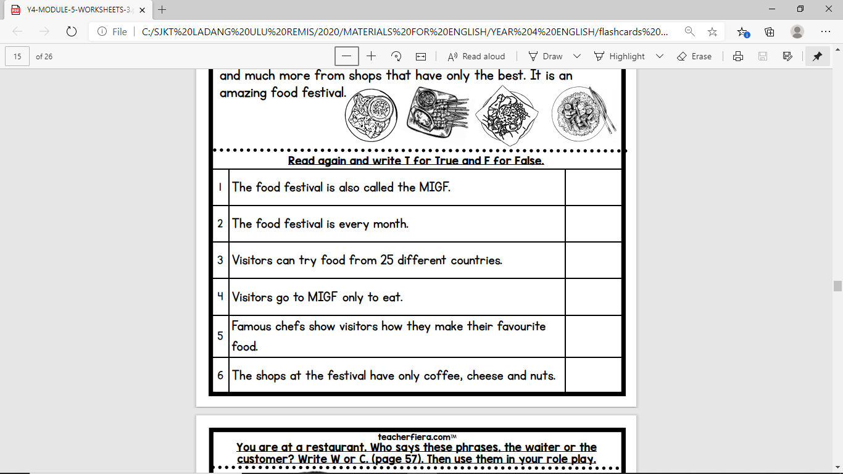

**(c) Look at the pictures. Then, answer the questions. (5 marks)**

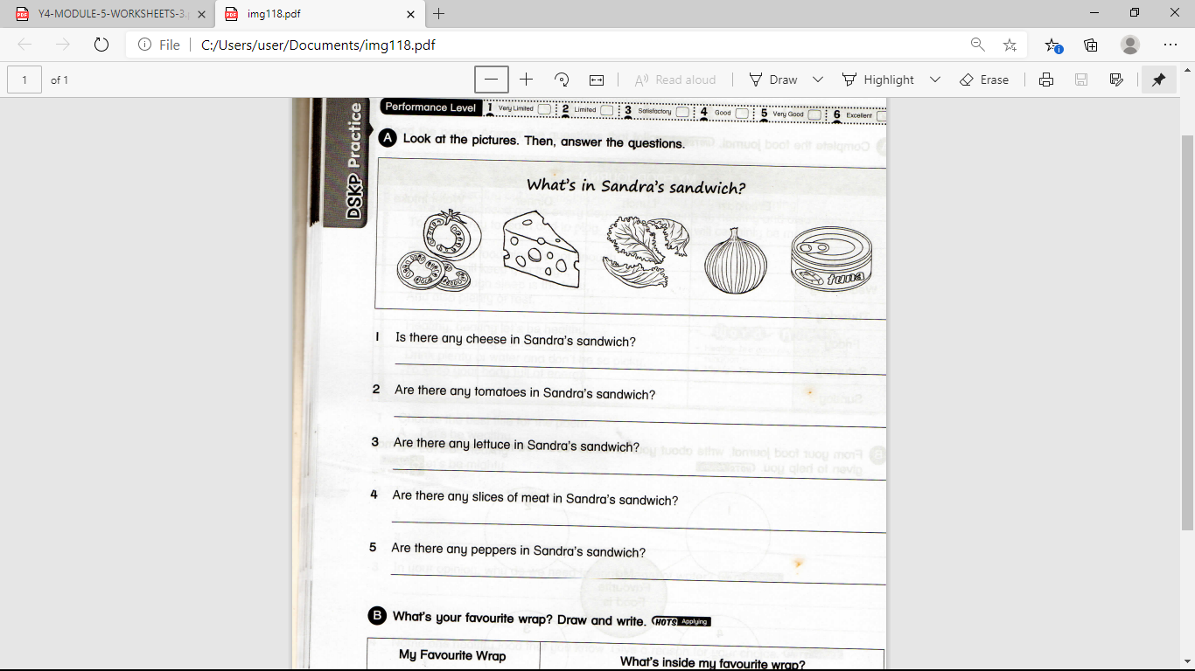

1. **Is there any cheese in Sandra’s sandwich?**
2. **Are there any tomatoes in Sandra’s sandwich?**
3. **Are there any lettuce in Sandra’s sandwich?**
4. **Are there any slices of meat in Sandra’s sandwich?**
5. **Are there any peppers in Sandra’s sandwich?**

**QUESTION PAPER ENDS**